Conflict Resolution Strategy
During the assignment, a merge conflict occurred when the feature/multiply-function branch and the feature/divide-function branch modified the same lines in the main.py file. In the multiply branch, the application version was changed from 1.0.0 to 1.1.0, while in the divide branch, the version was changed from 1.0.0 to 1.0.1. Both branches also updated the calculator version print statement. When merging the divide branch into the main branch after the multiply branch had already been merged, Git could not automatically decide which version of the conflicting lines should be kept, resulting in a merge conflict.
To resolve the conflict, the main.py file was manually reviewed and edited. The final version combined the functionality from both branches by keeping both the multiply and divide functions. The application version was updated to 1.2.0 as the final resolved version. The print statements were also updated to test all calculator operations successfully. After verifying the final code, the resolved file was staged using git add, and the merge was completed with a final merge commit.

Figure 1: Git Branch History and Merge Workflow
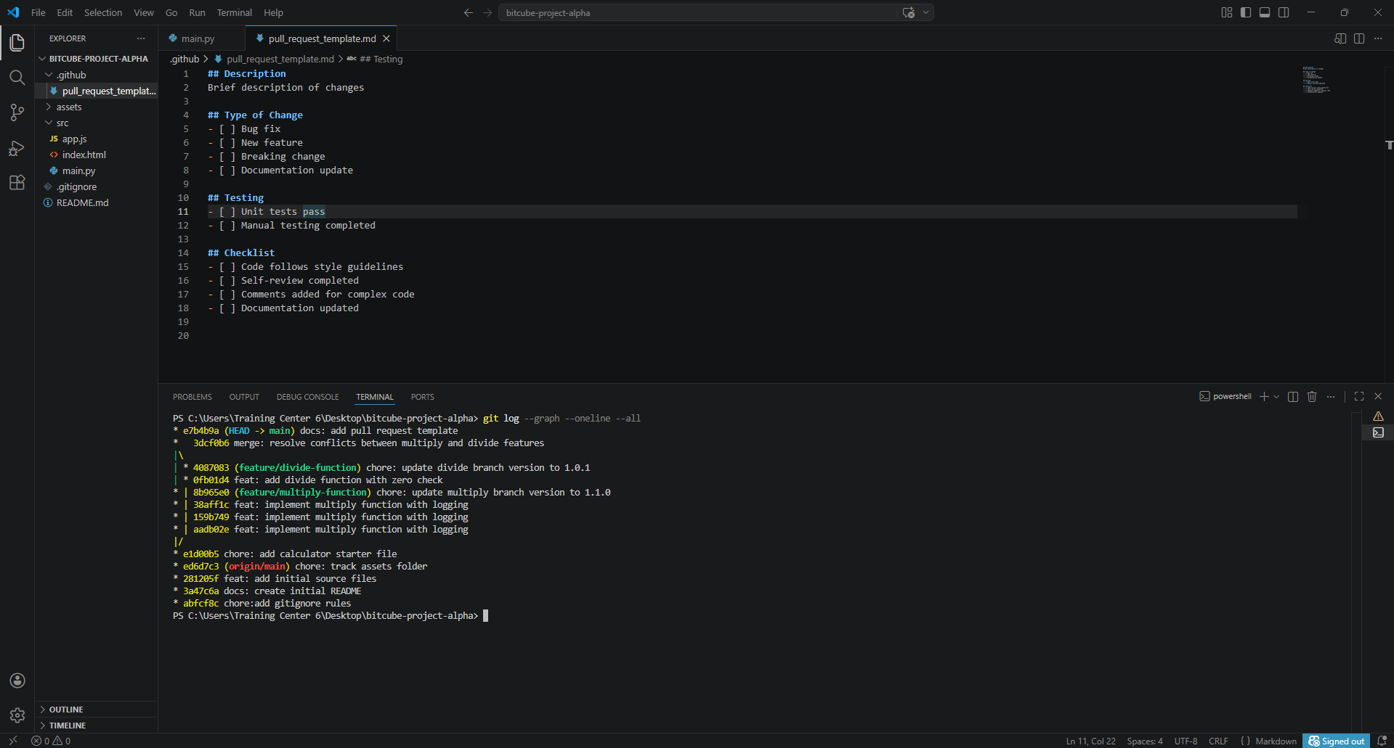

Figure 2: Main.py Screenshot
